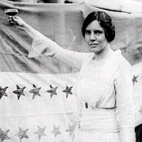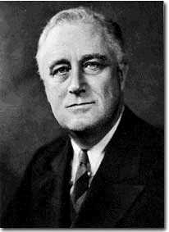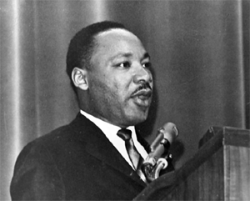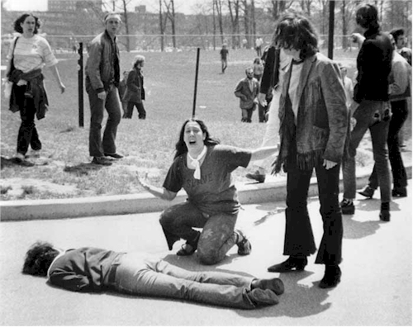


Palomar College Course Syllabus
History 102 – History of the United States Since Reconstruction
Instructor: Rose Darrough, M.A. American History, SDSU
Spring Session 2018 – RCC Campus

This course will generally follow a chronological approach to American history that will incorporate mainstream historical themes as well as other points of view of American history. My approach will include a combination of lectures, supplemental readings, discussions, and videos and/or slides. It is important to attend class regularly, participate in class activities, do the scheduled reading, and follow my lectures as the material from all of these components will form the basis for tests and quizzes.
Requirements:
- Read chapters assigned weekly from text.
- Respond to email and look at grade book. 10 points
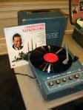
- Read pages assigned from- “Don’t Know Much about History” Questions will be assigned periodically and posted on Blackboard - approx. 40 points (10-20 points per assignment)
- Three Quizzes-90 points each (30 points per quiz)
- Mid-term Exam Ch. 22-25: approx. 120 points
- One research paper-100 points-subjects and format to be announced
RESEARCH PAPERS DUE: May 7th (6:00 pm)
- Final Exam Ch. 28-32-150 points
- Attendance/Participation –15 class meetings = 50 points (5 pts. for 1st day of class – 6 points for last day)
Total Points Available: Approx. 550 points

Grading Scale:
A= 90% or better, B= 80-89%, C=70-79%, D=60-69%, F=59% and below

*Extra Credit: 15 points-Students may do a 3-5 minute presentation on their research paper in class for 15 extra credit points. Papers turned in by 4/16 or earlier will get 5 extra credit points.

*Sign Up for Presentation Times for 4/16, 4/23, or 4/30

Expectations:

- Regular attendance and participation in class discussions/activities. (cell phones off or silent, no laptops)
- No make-ups on quizzes, tests, or research paper extension unless previously arranged w/ extenuating circumstances
- Be sure to officially drop or withdraw from the class if you plan on withdrawing. Notify the records office within the specified guidelines to avoid receiving an F for a final grade if your name is still on the roster for final grading
- Required readings:
America’s History-James Heneretta-6th Edition or later
Don’t Know Much About History-Ken Davis 2004 Edition or later
Giventer, Governing California 2nd Edition, 2007. (Not required – excerpts used from this text)
Primary Documents in class or other instructor provided class materials.
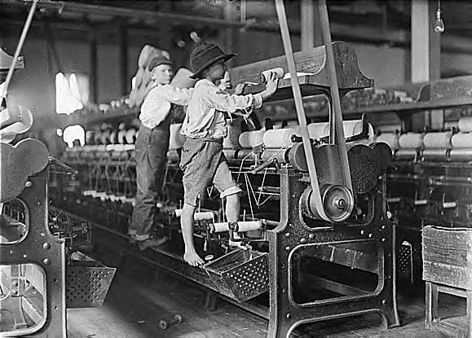
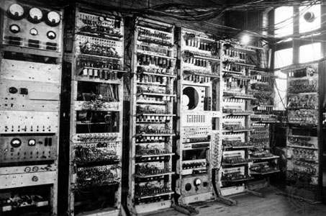

Calendar | Chapters/Lecture Topics | Reading Assignments
January 29th | - Introduction to class  - Review Syllabus  - Lecture Ch. 16 & 17 | - Read Ch. 16 + 17 Henretta by 2/5  - Read Ch. 5 Davis – Part 1  - Ch. 5 Davis ?s Part 1 Due: 2/5
February 5th | - Lecture Ch. 18 The Gilded Age – Quiz Review Ch. 16,17,18,19  - Choose Research Paper Topics  - Class Activity: The Pullman Strike  In class quiz – Ch. 16, 17, 18 on 2/12 | - Read Ch. 18 & 19 Henretta by 2/12  - Read Ch. 5 Davis – Part II  - Ch. 5 Davis ?s Part 1 Due: 2/5
February 12th | - Lecture Ch. 19 & 20  - Quiz – Ch. 16, 17, 18  - Choose Research Paper Topics  - Quizlet Live or Kahoot It | - Read Ch. 20 Henretta by 2/19  - Ch. 5 Davis ?s Part II Due: 2/26 6:00 p.m.
February 19th  Holiday | NO CLASS - Holiday | - Read Ch. 21 Henretta by 2/26  - Davis ?s Ch. 5 Part II due: 2/26  6:00 p.m.
February 26th | - Lecture Ch. 20 & 21 – Progressive Age + Foreign Policy  1877-1914  - Class Activity: Iron Jawed Angels  - Review Ch. 19, 20, 21 for Quiz 3/5 | - Read Ch. 22 & 23 Henretta by 3/5  - Review Ch. 19, 20, 21  - Excerpt from Giventer, Governing California – group activity with ?s
March 5th | - Quiz – Ch. 19, 20, 21  - Lecture Ch. 22 & 23 – WWI, 1920s  - Class Activity: Film – Scopes Trial | - Read Ch. 24 Henretta by 3/12  - Read Davis Ch. 6 by 3/12  - Davis ?s Ch. 6 Due: 3/12
March 12th | - Lecture Ch. 24 – Depression & New Deal; + WWII  - Class Activity: Graphing the Depression | - Read Ch. 25 Henretta by 3/19  - Davis ?s Ch. 6 Due: 3/12 6:00 p.m.
March 19th | - Lecture Ch. 25 – WWII  - Class Activity: Japanese Internment  - Mid-term Exam Review Ch. 22-25  - Quizlet Live or Kahoot.it | - Study for mid-term exam – Ch. 22-25  - Bring blue books & scan-trons on 4/2  - Midterm Study Guide – DUE: 4/3 6:00 p.m.
March 27th  Spring Break | Spring Break | - Read Ch. 26 Henretta by 4/2  - Read Davis Ch. 7 & Questions due: 4/16 – 6:00 p.m.
April 2nd | - Lecture Ch. 26& 27 – Cold War/1950s  - Class Activity: Truman & MacArthur or The Kennedy’s  - Quizlet Review Assignment | - Read Ch. 27 Henretta by 4/9  - Ch. 7 Davis ?s Due: 4/16 6:00 pm
April 9th | - Mid-term Exam – Ch. 22-25  - Lecture Ch. 27 – The Age of Affluence  - Class Activity: The Kennedy’s | - Read Ch. 28 Henretta by 4/16  - Review Ch. 26 & 27 for quiz on 4/16  - Ch. 7 Davis ?s Due: 4/16
April 16th | - Quiz – Ch. 26, 27  - Lecture Ch. 28 – The Liberal Consensus & Civil Rights  - Class Activity: Film – 2 Days in Oct.  - Student Presentations | - Read Ch. 29 by 4/23  - Ch. 7 Davis ?s Due: 4/16  - Excerpt from Giventer
April 23rd | - Student Presentations  - Lecture Ch. 28/29 – Vietnam thru Watergate | - Read Ch. 30 by 4/30  - Ch. 8 Davis by 5/14 + ?s due  - 6:00 pm
April 30th | - Student Presentations  - Lecture Ch. 30 - The Reagan Era, 1980s  - Class Activity: Nixon/Frost Film | - Read Ch. 31 by 5/7  - Davis ?s Ch. 8 Due: 5/14 6:00 pm
May 7th | - Lecture Ch. 31 - A Dynamic Economy, A Divided People – Clinton & George W. Bush Administrations  - RESEARCH PAPERS DUE – 6:00 pm  - Student Presentations | - Read Ch. 32 by 5/14  - Davis ?s Ch. 8 Due: 5/14
May 14th | - Lecture Ch. 32: Into the 21st Century  - Final Exam Review | - Davis ?s Ch. 8 Due: 5/14  - Final Exam Study Guides due 5/21 – 6:00 pm
May 21st | - Final Exam: Chapters 28-32  - Bring Green Books & scan-trons  - Final exam study guides due – 6:00 pm

Palomar College
Student Learning Outcomes for United States History
Instuctor: Rose Darrough
- HIST 101 Accurately interpret American history through the use of primary and secondary sources.
- HIST 101 Accurately recall knowledge of major events and figures in American history through Reconstruction
- HIST 101 Demonstrate college level writing in assessing and interpreting American history.
- HIST 101 Identify the historical and theoretical foundations of the U. S. Constitution, the structure and function of the three Branches, the Checks and Balances system, and the nature as well as the continuing impact of the Bill of Rights.
- HIST 101 Identify, use, and cite reliable primary and secondary sources in American.

- HIST 102 Accurately interpret American history through the use of primary and secondary sources.
- HIST 102 Accurately recall knowledge of major events and figures in American history through Reconstruction
- HIST 102 Demonstrate college level writing in assessing and interpreting American history.
- HIST 102 Demonstrate knowledge of nature and development of California's government and political system.
- HIST 102 Identify, use, and cite reliable primary and secondary sources in American.

